FUNCTION 1
2520030300
G.Nandini
STEP-1: CREATE TABLE
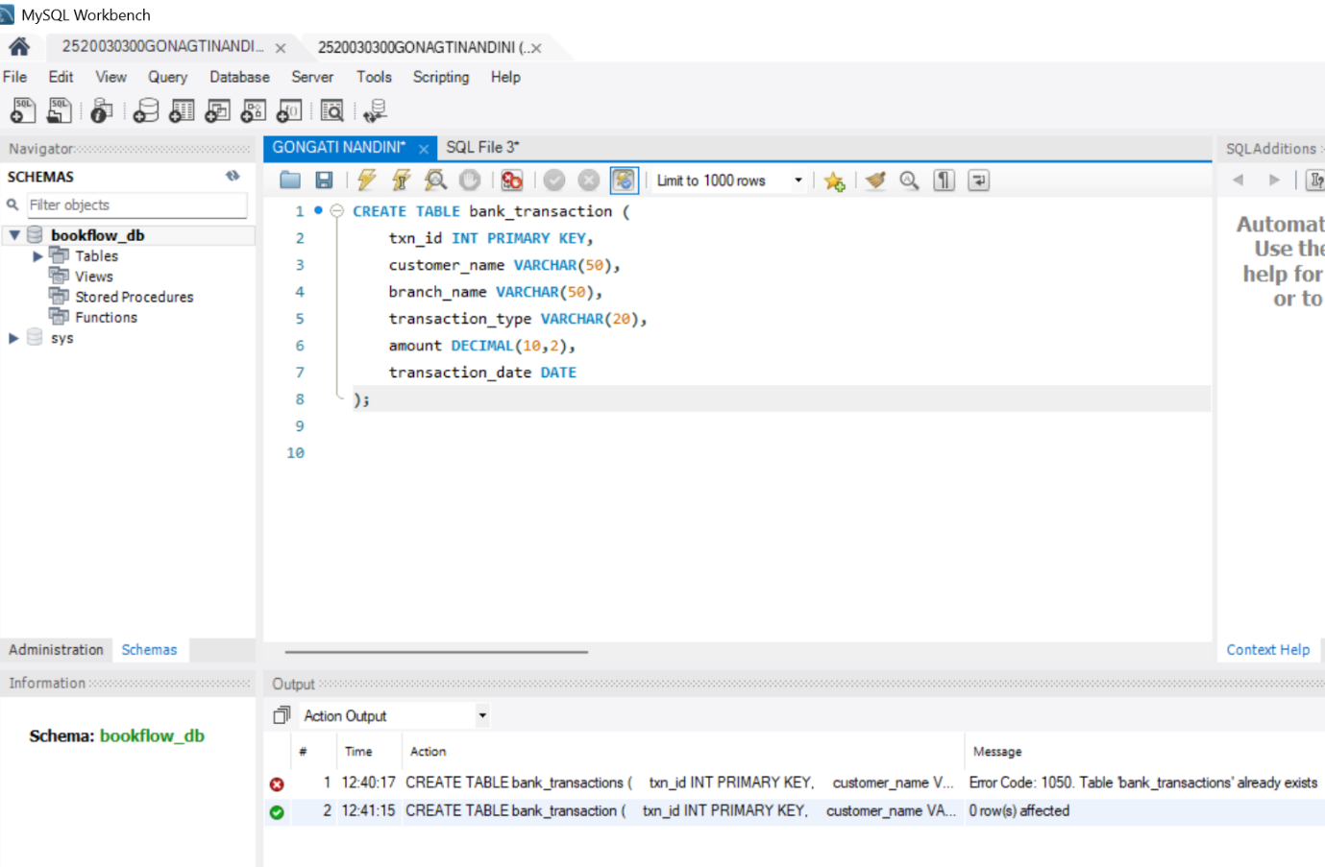
STEP-2: INSERT DATA
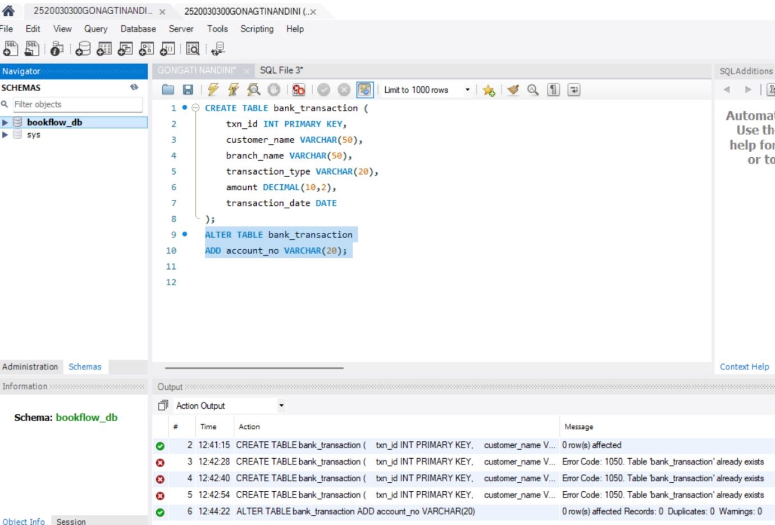
STEP-3: QUESTION 1 - SUM()
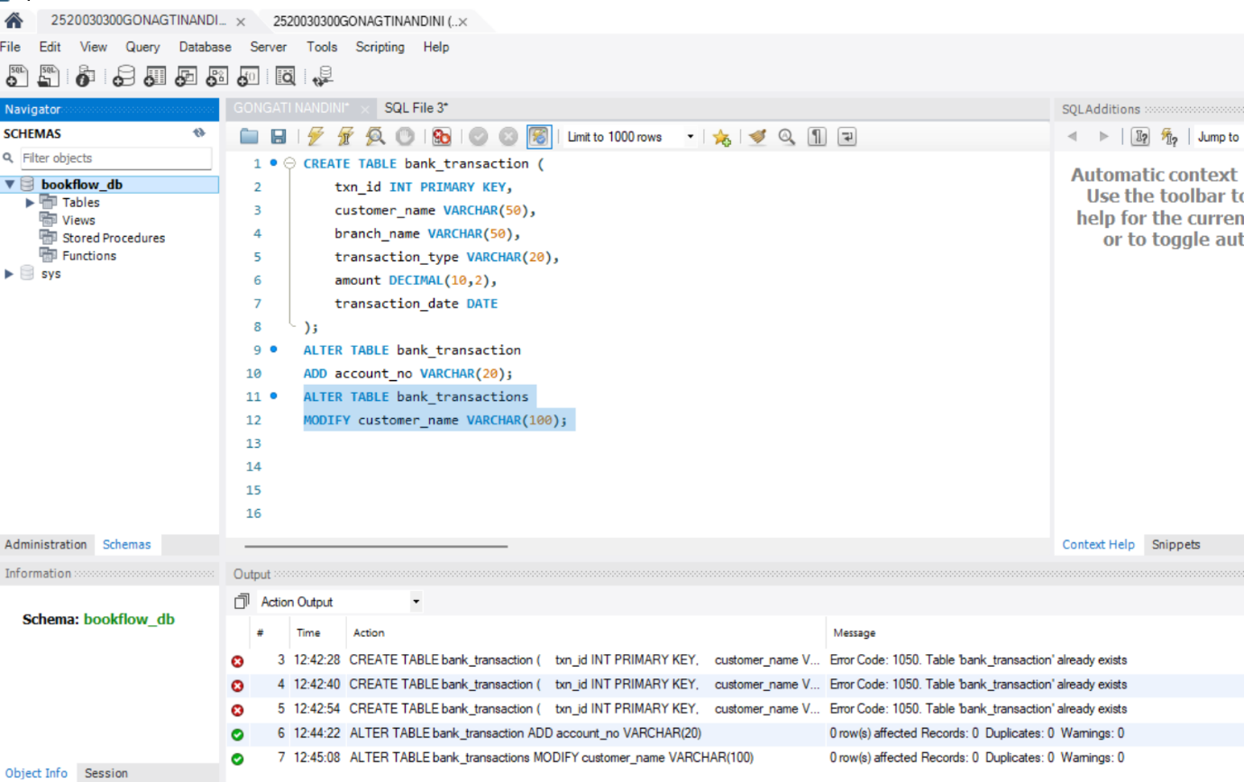
STEP-4: QUESTION 2 - AVG()
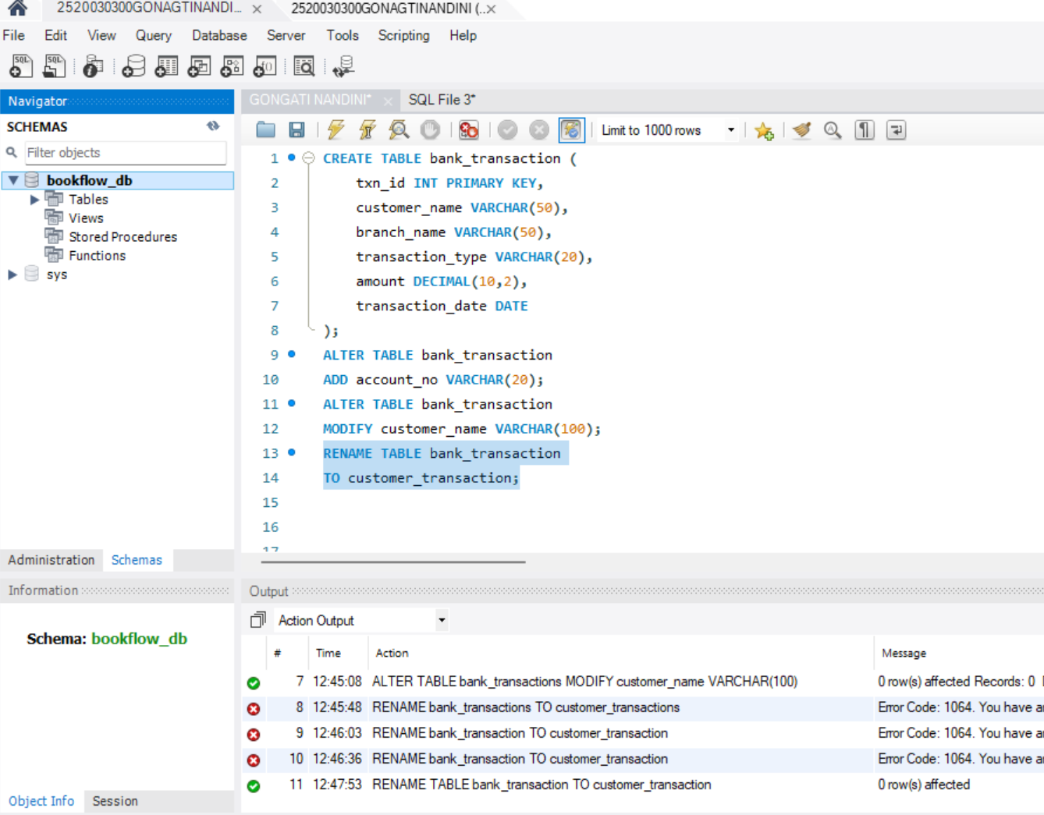
STEP-5: QUESTION 3 - MAX()
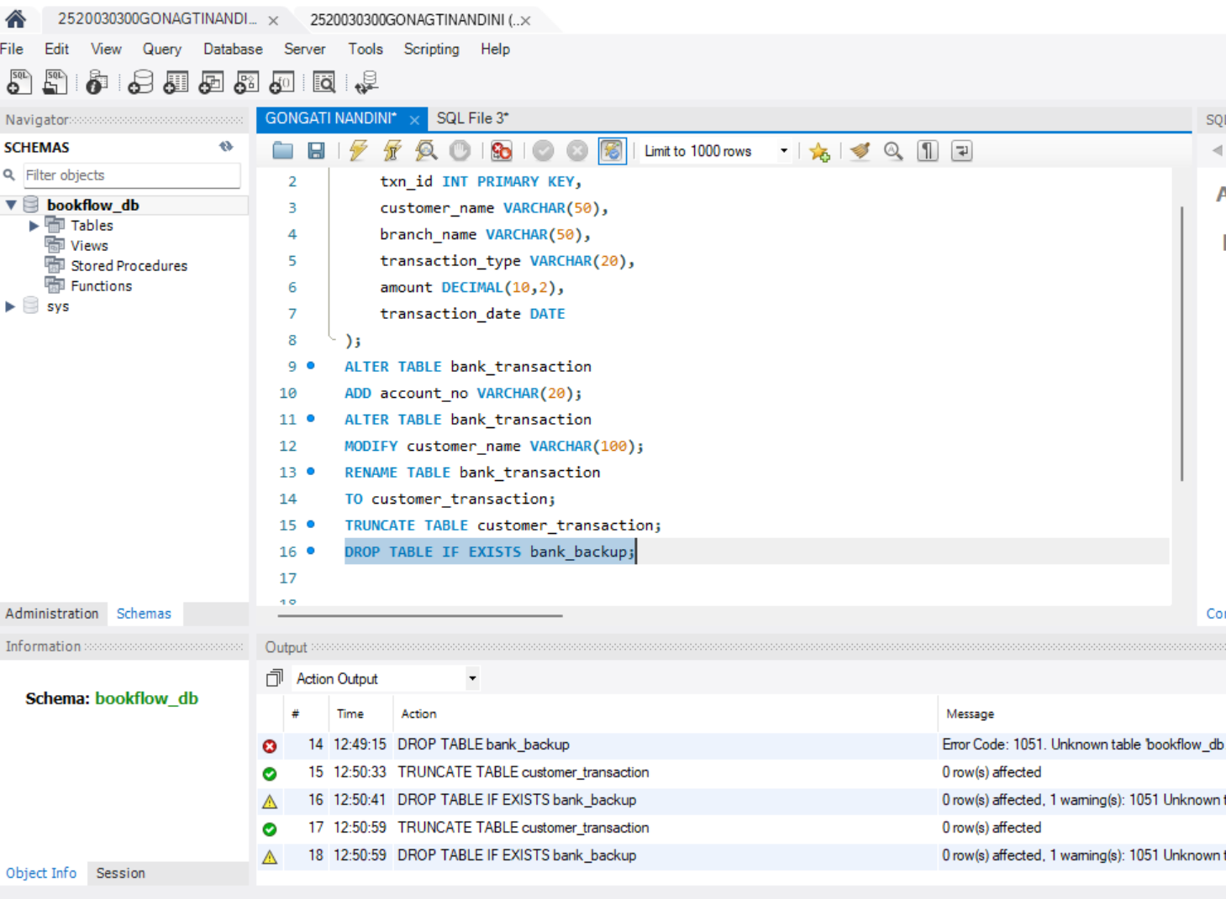
STEP-6: QUESTION 4 - MIN()
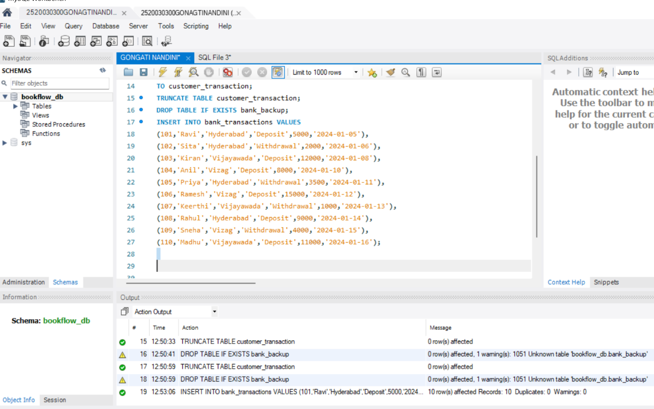
STEP-7: QUESTION 5 - COUNT()
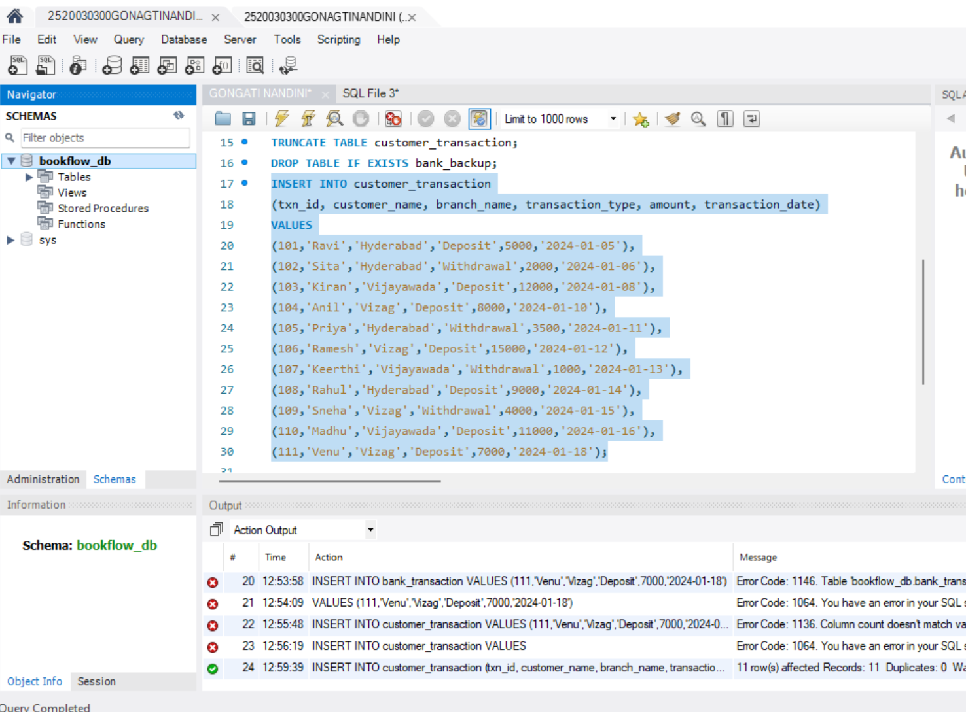
STEP-8: QUESTION 6 - WHERE + SUM()
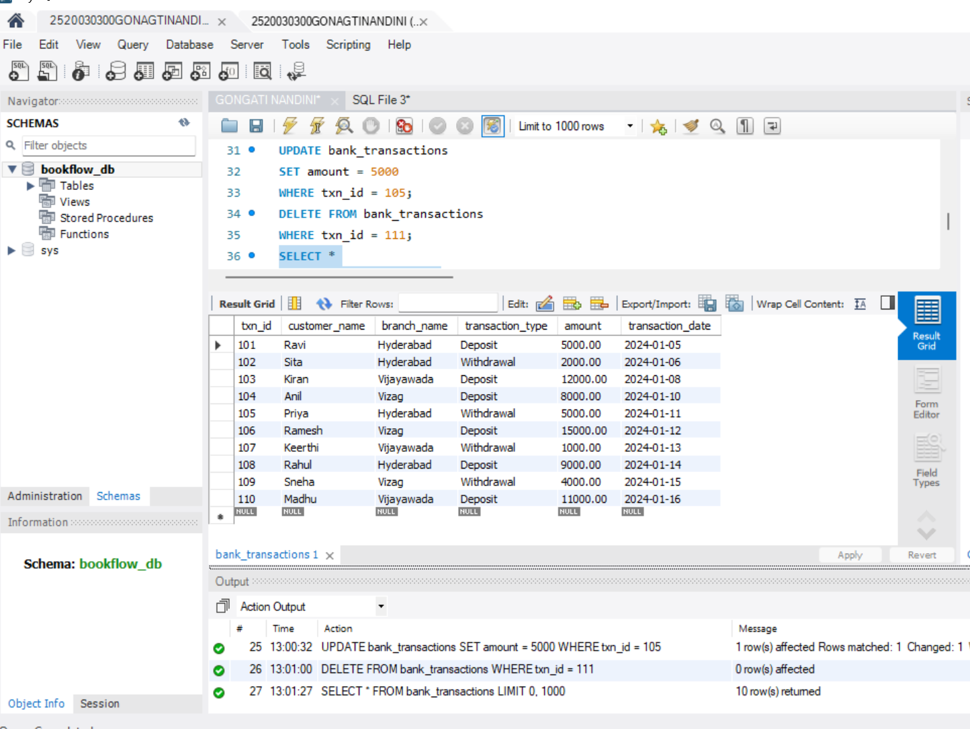
STEP-9: QUESTION 7 - GROUP BY
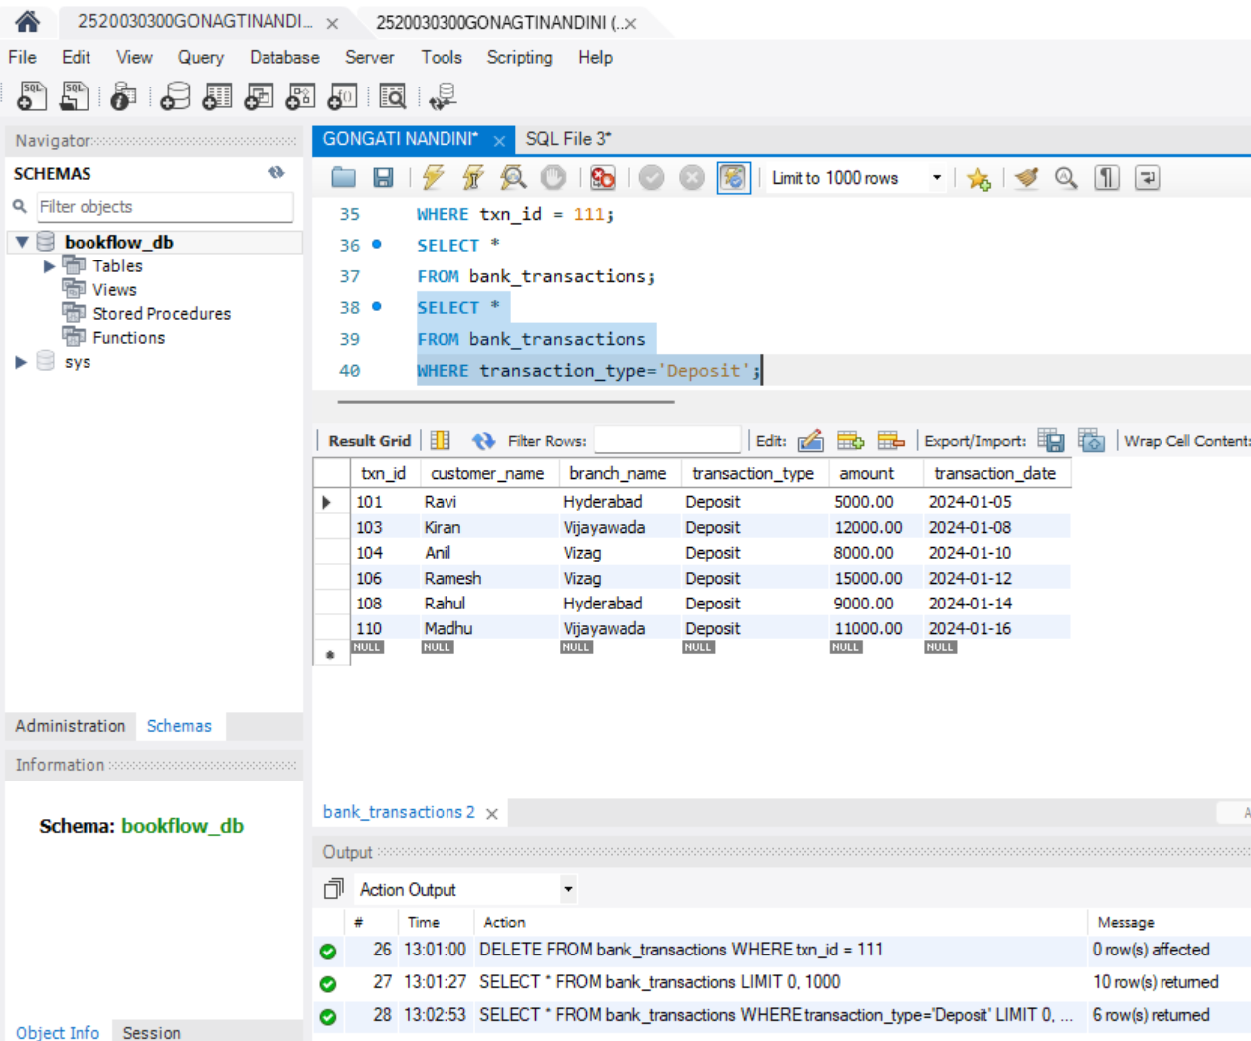
STEP-10: QUESTION 8 - GROUP BY + HAVING
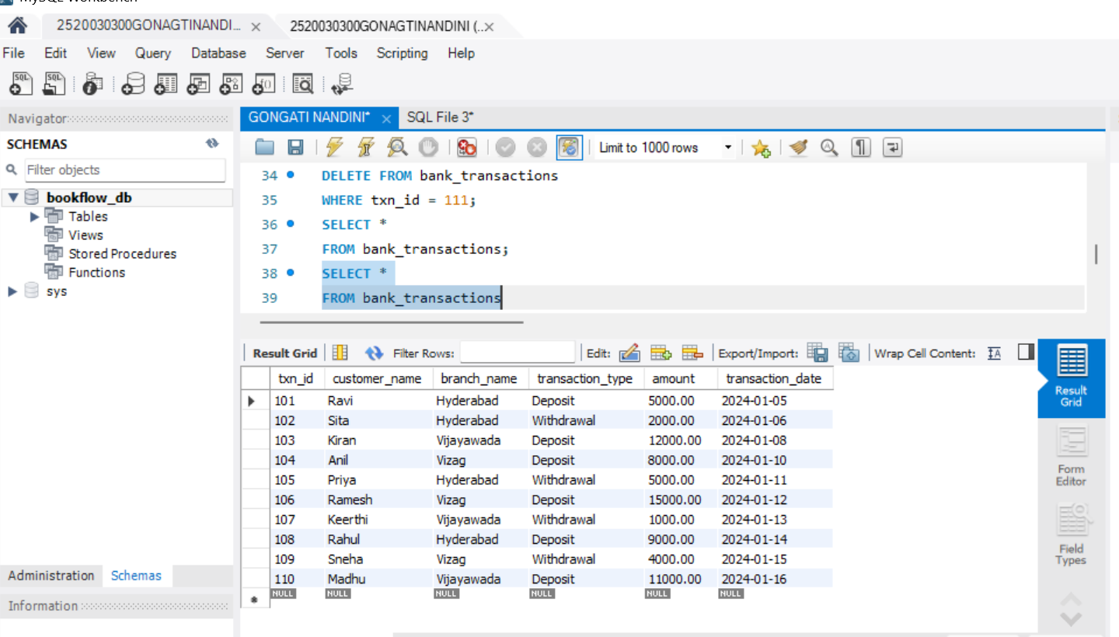
STEP-11: QUESTION 9 - GROUP BY + ORDER BY
